CS3021 Tutorial 6

Below is proof that my program generates the correct results for Q2:

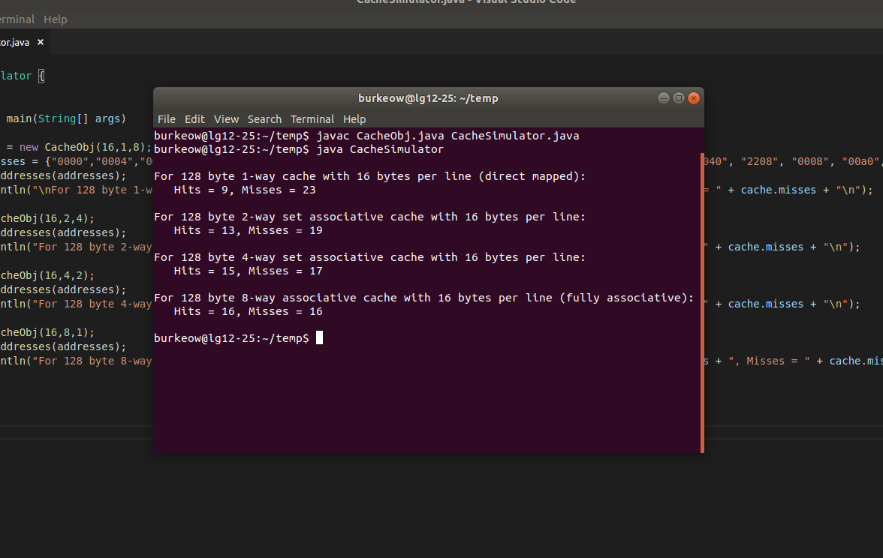
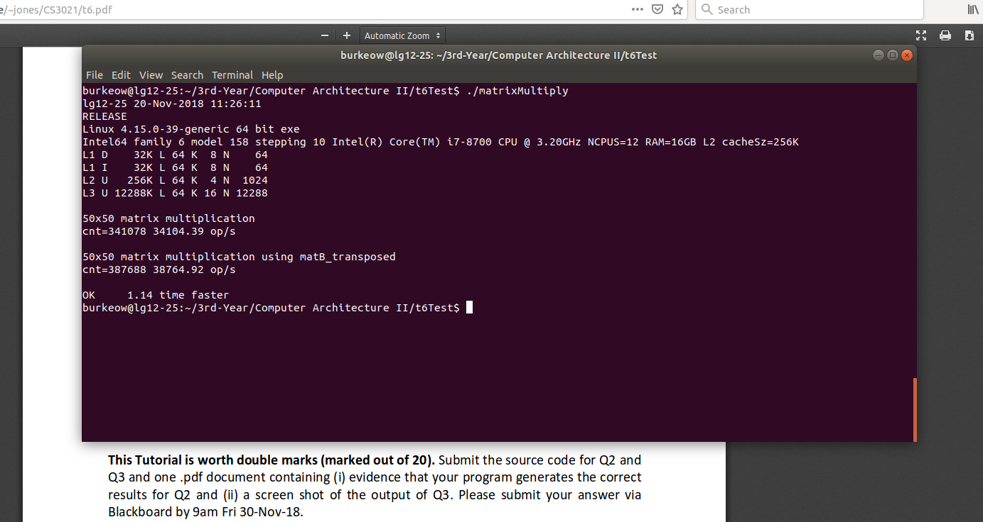
Below is a screenshot of the output for Q3:

